Welcome to the Jungle
An Open Legend Campaign
Introduction:
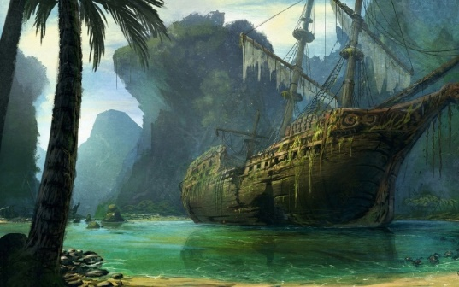
You wander through Freepoint, a frontier town on the Vanji River, from where numerous expeditions deeper into the Mwangi jungle start, seeing many treasure hunters, scholars, adventurers and cutthroats gathering in this town for the promise of invaluable treasures, long forgotten ruins and ancient magic.
These romantic dreams meet reality in Freepoint, as mosquitos swirl around your head, sweat and humidity drips down your face from the brutal heat of the jungle. Many expeditions never make it back to the town and those few which do are forever marred by the experience. But you’ll not be one of those folk. You’ll be one of the few who can relax and enjoy their exploits, one of the few to stand conquering hero of the Mwangi jungle. Your gaze is drawn towards the dark mass of green at the edge of the last safe haven before the dangers of the jungle start.
But danger is lurking from deep inside of the jungle, threatening to overrun Freepoint. Who were you able to save and where are you going to run, once the town has fallen?
Campaign Hook:
Become a leader of men, delegate resources and lay out a route to safety. You will be the head of a group of survivors from Freepoint, among them warriors, hunters, farmers and scholars, but also the elderly and the weak. Will you be able to keep them all safe?
Campaign Details:
Theme: Being on the run / having to make tough decisions.
Goals: Escorting a group of survivors to safety from a greater threat.
Setting: Jungle, standard fantasy.
Gameplay: Combat: 30%, Exploration: 40%, Interaction: 30%.
Tone: Serious, urgent, and fast-paced.
Experience Level: Players of all experience levels are welcome!
Duration: 10 to 12 sessions.
Schedule: Game is going to be run on Wednesdays between 6.00 pm and 11.00 pm CEST on Roll20. Sessions should last between two and three hours. Mic and Discord required.
Character Guidelines:
Alignments: There are no alignments in Open Legend, but being concerned about the well-being of your fellow refugees is expected.
Backstory: Characters need to have a reason for why they are in the jungle or want to explore it. This reason should be quite broad such as ‘I want to make a name for myself by finding lost relics’ rather than ‘I lost my girlfriend in there a couple hours ago and want to find her.’
Session 0: There will be a session 0, to help with character creation and system questions!
System Details:
Open Legend (www.openlegendrpg.com)
Starting Level 1
Standard Character Creation
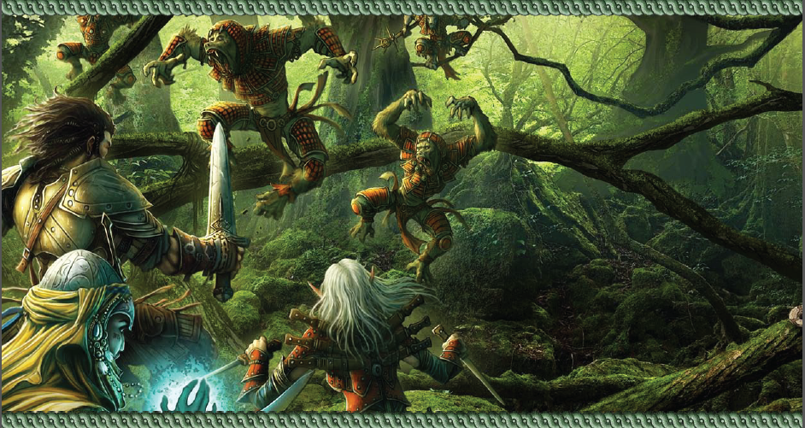
Additional Resources: https://openlegend.heromuster.com/

